Cyber AI Node (CAN)
A Continuous Cybersecurity AI Platform for Energy Hard-Tech
Marv Ahlstrom | Business Plan | October 27, 2026
Judge quick reference
Judging question | Short answer | Where
What's the hard tech? | A compact, high-memory edge computer (AMD Ryzen AI Halo) running local multi-agent AI over OT/ICS protocols, network, and physical signals | Sections 5, 8, 9
Show it working | Working telemetry simulation: synthetic substation replay, event correlation, evidence package, human-approved containment recommendation | Section 3
Who needs it? | Energy utilities and DER operators running remote substations, batteries, solar, and aging OT | Sections 1, 2
Why Utah? | Utah is adding remote, AI-linked generation fast: Creekstone's Delta Gigasite, Valar Atomics' Project Beehive, and Fervo's Cape Station | Section 1
What does $10,000 unlock? | AMD Ryzen AI Halo hardware for the first physical prototype, running the same demo fully on-device | Section 4
Contents
SUMMARY AND PLAN  1. Executive Summary  2. Five-Point Idea Analysis  3. Hackathon Build and Demonstration  4. Path to Reality and Use of Funds  MARKET  11. Market Context  12. Opportunity Sizing for This Concept | PRODUCT AND TECHNOLOGY  5. What Is a Hard-Tech Continuous Cybersecurity Edge Agent?  6. Why It's a Good Idea / Why It's Needed  7. What Already Exists Is Close but Not Identical  8. The 10 Core Functions  9. Detailed Product Plan and Specifications  10. High-Impact Realities and Disclaimers  THREATS AND DEPLOYMENT  13. Security Analogy  14. Real and Pending AI Threats  15. Remote Deployment Scenarios  16. Threat Scenarios and Product Disclaimers  Sources

1. Executive Summary

Hypothesis
For utility and distributed energy operators responsible for remote substations and OT environments who face AI-accelerated vulnerability discovery and cannot rely on constant cloud connectivity or immediate patching, the Cyber AI Node is a continuous cybersecurity edge agent appliance that analyzes network, OT, and physical signals locally, prioritizes high-consequence anomalies, and packages evidence for supervised response while keeping sensitive data on-site. Unlike centralized OT visibility platforms and cloud-based SOC tools, our solution runs multi-agent reasoning on a compact high-memory edge computer that continues operating under intermittent or air-gapped conditions and integrates as an analysis layer rather than a full replacement.

Why Utah
Utah is building some of the most ambitious new energy infrastructure in the country, much of it at remote sites tied directly to AI data centers. Each is the kind of distributed, high-consequence OT environment the Cyber AI Node is built to protect:
- Creekstone Energy's Delta Gigasite (Millard County): A $17 billion power and AI data center campus near Delta, planned around on-site natural gas generation and utility-scale solar, with up to 10 GW of capacity at full build-out. Area Development, AI Magazine
- Project Beehive (Valar Atomics, near Price): A proposed data center campus powered by 456 small nuclear reactors on more than 9,000 acres of BLM land, producing about 9.6 GW. NPR via KUNC
- Fervo Energy's Cape Station (Beaver County): The world's first greenfield Enhanced Geothermal System (EGS) to reach commercial operation. Its first 33 MW net GeoBlock synchronized to the grid on September 24, 2026 and began commercial operation on September 30, 2026. Renewable Energy Magazine
These projects pair new generation with on-site compute, remote locations, and limited local staff. That's where local, offline-capable security analysis matters most. Our goal is to build, pilot, and grow the Cyber AI Node here in Utah alongside them.

Product Overview

Short description
An on-site AI brain for remote infrastructure security.

Long description
The Cyber AI Node is a continuous cybersecurity AI platform: a compact, on-site AI appliance, built on the AMD Ryzen AI Halo, that continuously monitors remote hard-tech operational technology environments, analyzes local telemetry with multi-agent reasoning, and supports supervised defensive actions while keeping sensitive data on-premises.

Why is this needed
Energy systems, AI infrastructure, defense contractors, and aerospace sites face rising OT/ICS threats, regulatory pressure (NERC CIP, TSA, NIS2), and persistent skills shortages. Centralized tools and cloud AI often fail when connectivity is intermittent, data must stay local, or response must be immediate and auditable.

Competitive landscape
Established OT visibility platforms (Dragos, Nozomi, Claroty) and SOC tools provide strong monitoring and detection. What remains limited is continuous, high-capability local analysis and constrained defensive support at remote or air-gapped sites without shipping raw data or relying on constant cloud connectivity.

Core capabilities
- Continuous local ingestion and correlation of network flows, OT protocols, logs, and configuration baselines
- Multi-agent reasoning that prioritizes high-consequence anomalies and packages evidence
- Supervised autonomy with human-gated containment recommendations or limited actions
- Offline/intermittent operation, data residency, and modular adaptation across energy, AI infrastructure, defense, and aerospace
- Integration path with existing OT tools and enterprise control planes rather than full replacement

Honest constraints
The platform does not autonomously shut down industrial processes, replace certified OT security products, or eliminate the need for human operators and compliance processes. Power, thermal, and certification limits constrain continuous high-load inference. Early deployments will be supervised pilots, not fully autonomous fleets.

2. Five-Point Idea Analysis

1) Customer Pain
Target customer: Utility and distributed energy operators (and other hard-tech site owners) responsible for remote substations, generation, batteries, and OT/ICS environments.
Job to be done: Continuously detect and contain cyber threats to critical equipment when connectivity is intermittent, raw data cannot leave the site, and patches cannot be applied immediately.
Current pain:
- Frontier AI models can discover and exploit vulnerabilities faster than traditional patching and centralized response cycles.
- Growing numbers of sensors and remote devices expand the attack surface.
- Central SOCs receive too many alerts with too little local context.
- Operators cannot export sensitive OT telemetry to the cloud.
- Limited on-site staff and specialized OT+AI talent.
Pain intensity: High. Frequency is rising as connectivity and AI-assisted attack capability increase.

2) Market Potential
Energy & Power is a large share of the multi-billion-dollar OT/ICS cybersecurity market. Adjacent hard-tech sectors (AI infrastructure, defense, aerospace) expand the opportunity. Growth is driven by regulation (NERC CIP, etc.), nation-state activity, and AI-accelerated threats. Sustainability is high if the solution reduces investigation time and retains data on-site.

3) Solution
Product name: Cyber AI Node
Category: Continuous cybersecurity edge agent appliance (local multi-agent analysis + supervised response support)
Key benefit: Local, continuous correlation of network, OT, and physical signals that prioritizes high-consequence anomalies and packages evidence, even when offline, so operators can act faster without exporting raw data.
Differentiation: Compact high-memory edge platform capable of meaningful local multi-agent reasoning, positioned as an analysis layer that augments (does not replace) existing OT visibility tools.

4) Positioning in the Market
Primary competitive alternatives: Centralized OT platforms (Dragos, Nozomi, Claroty) + cloud/SOC AI.
Positioning: “Local AI brain for remote hard-tech sites”: continuous on-device analysis under data-residency and connectivity constraints, with human-gated actions.

5) Path to the Exit / Reality
Phase 1: Halo hardware + 2–3 supervised energy pilots. Validate reduced investigation time and offline continuity. Modular expansion to other hard-tech sectors after validation. The $10k bounty specifically unlocks the first physical Halo prototype.

3. Hackathon Build and Demonstration
This week we completed a working telemetry simulation. It replays synthetic substation data (unfamiliar device, cabinet intrusion, unexpected command) and shows event correlation, operator alert with evidence package, and a containment recommendation with simulated human approval.
Deliverables: running dashboard, repeatable replay, and event log.
This proof of concept demonstrates the local analysis workflow ahead of Halo hardware.

4. Path to Reality and Use of Funds

Concrete plan
Phase | Timeline | Milestone
Phase 1 | Months 1–6 | Deploy reference Halo units at 2–3 energy pilot sites; integrate passive telemetry; validate local anomaly prioritization and evidence generation against existing tools. Measure investigation time, false alerts, offline continuity, and power/thermal.
Phase 2 | Months 6–18 | Add supervised response workflows, sector-specific modules (NERC CIP evidence, OT protocol depth), and multi-node coordination.
Phase 3 | After validation | Expand to AI infrastructure, defense, and aerospace sites; pursue formal integration and compliance pathways.

Prize funding and next milestone
The $10,000 award purchases AMD Ryzen AI Halo development hardware for the first physical prototype. Funded milestone: run the identical demonstration entirely on Halo and benchmark local inference, data retention, continuous operation, and offline resilience.

Customer value and business model
Integrates with existing utility security tools. Demonstrates reduced investigation time for high-consequence findings while retaining data on-site. Model: appliance + per-site software/support subscription, validated through pilots.
The result is a path from concept to measurable operator value (faster investigation, retained data control, and a foundation for constrained local defense) while retaining full ownership and focusing on hard-tech constraints that general cybersecurity tools do not fully address.

5. What Is a Hard-Tech Continuous Cybersecurity Edge Agent?
A compact, always-on edge appliance (built on the AMD Ryzen AI Halo platform) that runs multi-agent AI locally to continuously monitor, correlate, and reason over cybersecurity and operational telemetry in remote hard-tech environments.
It acts as a persistent 24/7/365 local security agent that:
- Ingests network flows, logs, OT/ICS protocol data, and configuration telemetry
- Performs multi-step analysis and long-context reasoning entirely on-device
- Surfaces high-confidence findings, evidence packages, and recommended actions
- Operates with supervised autonomy (human-gated for high-impact actions)
- Maintains full data residency and continues functioning under intermittent or air-gapped connectivity
Primary focus of this version: energy sector (substations, distributed energy resources, OT/ICS).
Future modular extensions: AI infrastructure, defense contractors, aerospace systems, and other hard-tech environments.

Hardware: AMD Ryzen AI Halo
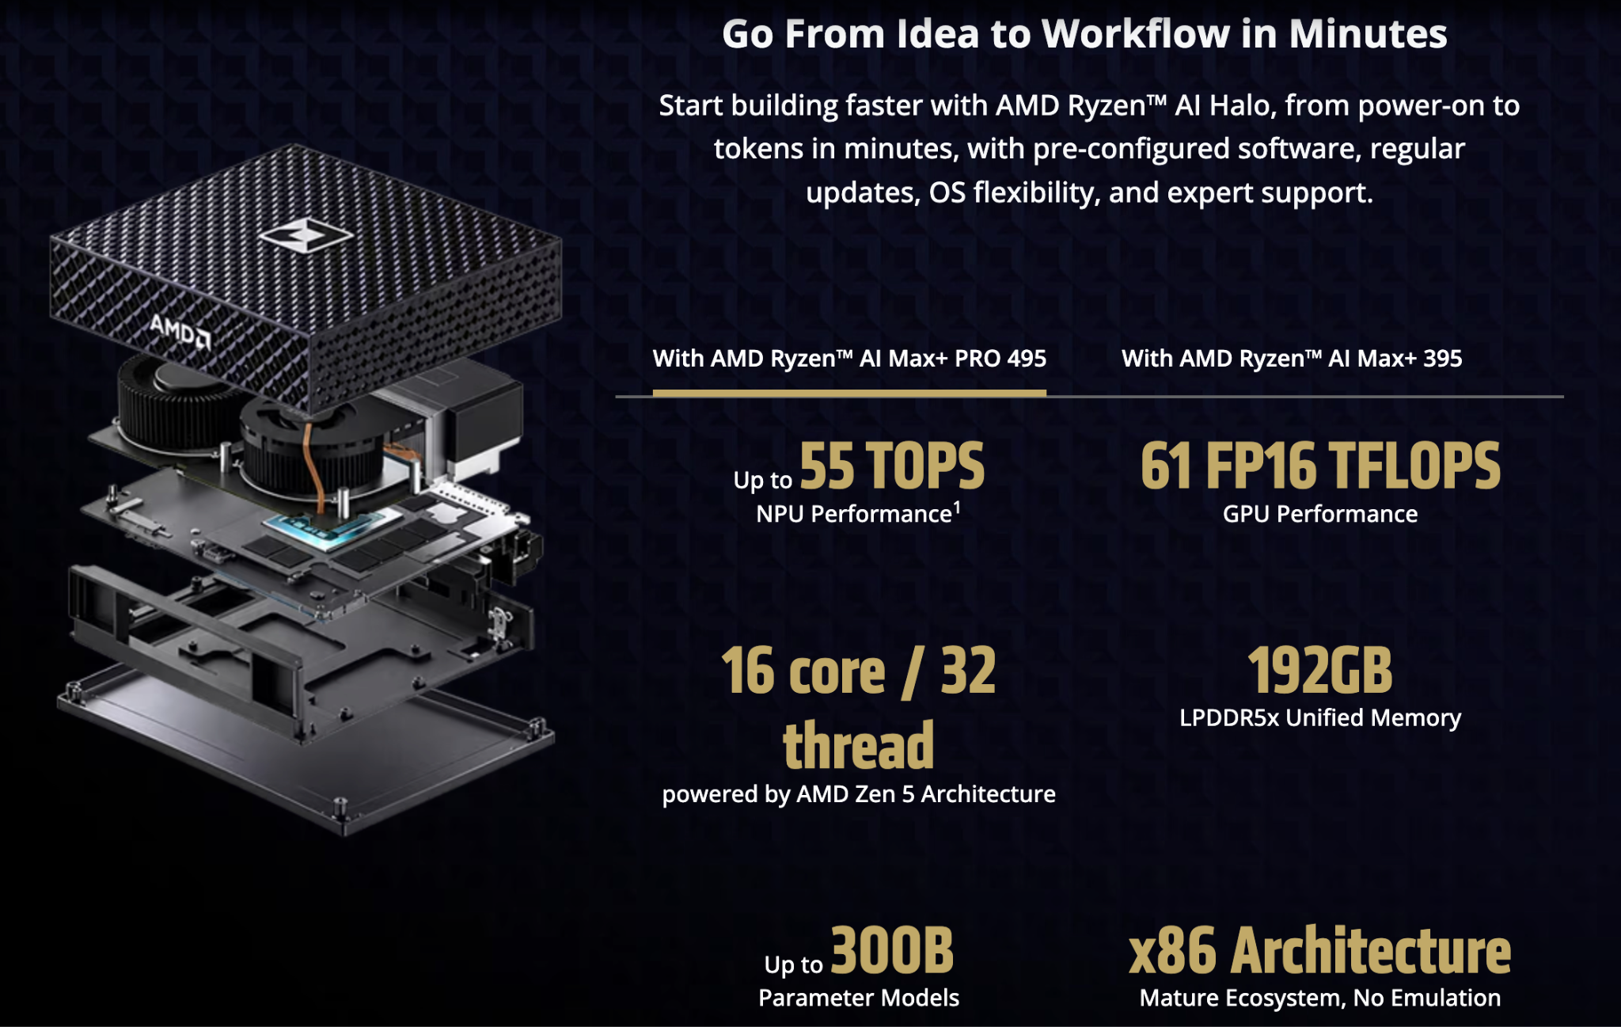

Why the AMD Ryzen AI Halo hardware foundation? It is built for open frameworks and comes pre-installed with the AMD Ryzen AI Halo Developer Center app, a central hub for developers to easily access playbooks, tools and updates.
Specs: high unified memory (128–192 GB), local LLM inference capability, 10 GbE networking, low continuous power (~120 W), compact form factor, and enterprise management hooks (e.g., Cisco DefenseClaw, observability, policy enforcement).

1) Easy setup: leverage AMD AI Playbooks, with a guided learning path for developers, including quick setup.
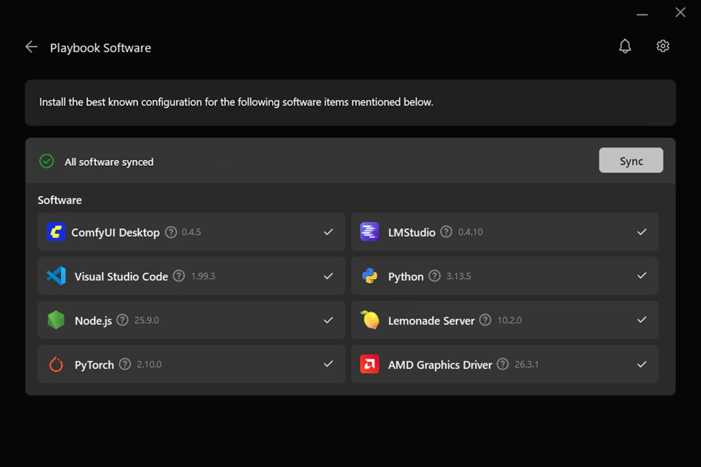
2) AMD Ryzen AI Developer Center: aligns with validated software configurations for optimal performance, and seamlessly access and manage pre-installed tools.
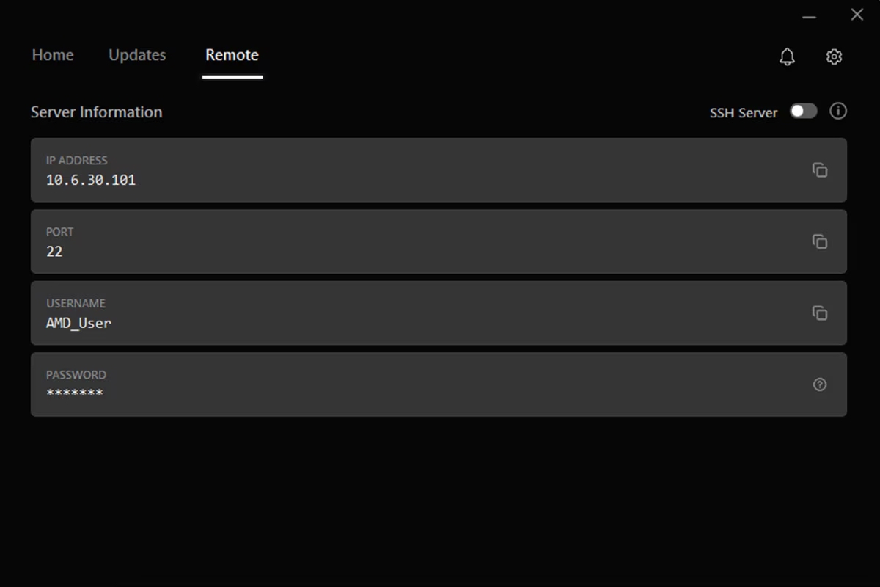
3) Remote management: AMD Sync desktop application lets users seamlessly monitor and manage AMD Ryzen AI Halo from another device.

6. Why It's a Good Idea / Why It's Needed
- Accelerating threat landscape: Frontier AI models can now plan and assist OT attacks rapidly (lab demonstrations show perimeter-to-control actions and physical equipment movement in minutes). Defenders need continuous local correlation and reasoning at the same speed.
- Data sovereignty and connectivity constraints: Hard-tech sites often cannot send raw telemetry to the cloud. Local large-model analysis keeps sensitive data on-site and works through intermittent links or air gaps.
- Alert fatigue and skills gap: Existing tools generate volume; operators lack time and specialized OT+AI talent to investigate everything. A local multi-agent system can triage, enrich, and prioritize findings with process context.
- Hardware readiness: Compact high-memory edge platforms now support models large enough for meaningful multi-agent workflows, long-context log analysis, and tool use, without constant cloud dependency.
- Hard-tech specificity: Generic cloud SIEM or light edge ML does not adequately handle OT protocols, physical consequence weighting, or regulatory constraints (NERC CIP, IEC 62443, etc.). A purpose-built edge agent fills the gap between traditional OT sensors and full private-cloud SOC appliances.

7. What Already Exists Is Close but Not Identical
Strong adjacent solutions exist, but none fully combine a compact high-memory local LLM agent platform with continuous hard-tech cybersecurity monitoring:
- Industrial/OT platforms (Schneider Electric + NVIDIA + HPE edge agents, Seceon OTM, Industrial Defender, Nozomi, Claroty, Dragos, Fortinet OT): Excellent protocol visibility, asset intelligence, and anomaly detection. Typically heavier infrastructure or focused on visibility rather than multi-step generative agent reasoning.
- Agent governance layers (Cisco AI Defense / DefenseClaw, NVIDIA Sentry, Palo Alto Cortex Agentic Endpoint Security, Trellix Wise): Strong on securing and controlling agents, observability, and policy enforcement. Less focused on being the primary continuous monitoring and analysis agent.
- On-prem / air-gapped SOC AI and research systems: Address data residency and some agentic workflows, but usually larger systems or not optimized as always-on edge appliances for hard-tech sites.
Differentiation: Compact form factor + large local models for multi-agent reasoning + local-first data handling + supervised autonomy + modular hard-tech adaptations. Positioned as an intelligent analysis and prioritization layer that augments (rather than replaces) existing OT visibility platforms.

8. The 10 Core Functions
- Continuous telemetry ingestion: Network flows, logs, OT/ICS protocols (Modbus, DNP3, IEC 61850, etc.), asset configs, and event streams.
- Local multi-agent analysis: Persistent agents perform correlation, long-context reasoning, and multi-step investigation entirely on-device.
- Anomaly and threat detection: Baseline deviation, protocol-aware anomalies, and known vulnerability correlation.
- Evidence packaging and prioritization: Structured findings with supporting data, confidence scores, and physical-consequence weighting.
- Supervised autonomy and action gating: Observe → recommend → act-with-approval tiers; high-impact actions require human confirmation or dual control.
- Audit and explainability: Full contemporaneous logs of inputs, reasoning traces, tool calls, and outputs for compliance and operator trust.
- Integration and enrichment: Consumes data from existing OT platforms/historians/SIEMs and adds agentic analysis; returns advisory outputs.
- Sector-specific modules: Energy OT/ICS focus first; configurable packs for AI infrastructure integrity, defense configuration baselines/SBOM, aerospace systems, etc.
- Resilient offline/intermittent operation: Continues core monitoring and analysis without cloud connectivity; secure synchronization when available.
- Fleet governance and management: Policy enforcement, observability, quarantine capability, and centralized control (leveraging partnerships such as Cisco).

Conclusion on functions: Together these create a continuous, local, auditable security agent that reduces investigation burden, improves prioritization of high-consequence findings, and respects the operational and regulatory constraints of hard-tech environments.

9. Detailed Product Plan and Specifications

Hardware platform
- AMD Ryzen AI Halo: 16 Zen 5 cores, Radeon iGPU, XDNA 2 NPU, 128–192 GB unified LPDDR5x, 10 GbE, ~120 W continuous, compact form factor.
- SED storage, isolated agent sandbox, ROCm software stack.
- Optional ruggedization and UPS for remote energy/field sites.

Monitoring targets
- Network traffic volume: Site-dependent (substation/control network flows, typically low-to-moderate volume with protocol focus).
- Log sources: Historians, firewalls, switches, OT protocol logs, asset configuration baselines, security events.
- Vulnerability scanning scope: Passive + configuration correlation; active scanning only under controlled windows.
- Autonomy level: Observe and recommend (default); act-with-approval for low-risk enrichment; no autonomous high-impact OT actions.
- Connectivity: Fully local operation; optional secure outbound for threat intel updates or fleet management.
- Sector options: Swap protocol packs, consequence models, and compliance mappings (AI infra model integrity, defense SBOM/config baselines, aerospace, etc.).

Agent architecture
- Multi-agent orchestration on local models (vLLM / llama.cpp / Lemonade).
- Tool calling limited to approved, scoped functions.
- Human-in-the-loop gates and external policy enforcement (Cisco DefenseClaw or equivalent).
- Continuous self-monitoring and audit logging.

Deployment model
- Pilot: Advisory-only, outside ESP, integrated with existing OT visibility tools.
- Scale: Fleet management, sector modules, gradual increase in assisted actions after validation.
- Path to reality: Working prototype on Halo hardware → domain fine-tuning and representative telemetry testing → pilot with energy partner → modular expansion.

Success criteria
- Measurable reduction in investigation time for high-consequence findings.
- Operator trust (low false-positive rate on validated cases).
- Full auditability and regulatory alignment.
- Continued operation under connectivity constraints.

10. High-Impact Realities and Disclaimers
These are the practical constraints that must be addressed for viability:
- Data quality and context: Incomplete asset inventories or noisy telemetry lead to hallucinations or useless output. Strong enrichment or tight integration with existing OT platforms is required.
- False positives in OT: Incorrect recommendations can cause unnecessary isolation or safety impacts. Domain tuning, high confidence thresholds, and consequence weighting are mandatory.
- Regulatory placement: In energy, the appliance should typically sit outside the NERC CIP Electronic Security Perimeter (or equivalent), consuming controlled data and producing advisory outputs only. Full audit trails are required.
- External controls: Engineering limits, unique agent identities, least-privilege tools, network segmentation, and tested kill switches must sit outside the agent itself.
- Integration over replacement: Success depends on augmenting existing tools (Dragos, Nozomi, Claroty, etc.) rather than competing as a full visibility platform.
- Operator trust and skills: Heavy human oversight early on; clear explainability; gradual autonomy increases only after validation.
- Operational realities: Power, cooling, physical security, ruggedization for remote sites, model/update change control, and long-term support model.
- Agent security: The platform is a high-value target. Goal hijacking, prompt injection via logs, tool misuse, and rogue behavior must be mitigated by design.
Early deployments should be advisory-only, read-focused, and heavily validated before any expansion of autonomy.

11. Market Context
Market size and opportunity for a Hard-Tech Continuous Cybersecurity Edge Agent Platform
The broader OT and critical infrastructure cybersecurity markets are large, growing, and under pressure from both threats and regulation. A focused hard-tech continuous edge agent platform addresses a real and expanding gap (local high-capability analysis under data-residency and connectivity constraints). The opportunity is attractive but is best pursued as a specialized layer that augments existing tools rather than a full-market replacement play. Early energy pilots, clear regulatory positioning, and measurable operator value will determine how much of that opportunity is realistically capturable.
The opportunity sits at the intersection of three overlapping and fast-growing segments: OT/ICS cybersecurity, energy & critical infrastructure protection, and edge AI for security. These are not identical markets, but the proposed platform addresses a specific gap within them (local, high-capability agentic analysis for hard-tech sites).

Global OT/ICS cybersecurity market (most relevant base)
- Estimates vary by scope and methodology:
  - ~$22–25 billion in 2025, growing to $50–70+ billion by early 2030s (CAGR commonly cited in the 14–16% range). Pmarketresearch
  - One 2026 forecast: ~$27.4 billion in 2026 → ~$59 billion by 2031 (16.6% CAGR). Dri
  - Another: ~$24.7 billion in 2024 → ~$95 billion by 2030 (higher CAGR in some reports reflecting broader inclusion of services and IT/OT convergence).
- Energy & Power is consistently one of the largest verticals (often 20–25%+ of OT cybersecurity spend). Oil & gas OT cybersecurity alone is estimated around $2.9 billion in 2025, growing toward $5–9 billion by the mid-2030s. Strategicrevenueinsights

Critical infrastructure protection (broader CIP market)
- Global CIP market roughly $140–160 billion in 2025/2026, projected to reach $200–270 billion by the early 2030s (CAGR ~5–11% depending on inclusion of physical security).
- OT/ICS cybersecurity is repeatedly identified as the fastest-growing segment within CIP as connectivity, ransomware, and nation-state activity increase. Globenewswire

Edge AI for cybersecurity / AI-enabled critical infrastructure defense
- Edge AI security is growing extremely rapidly in analyst projections (CAGR often 20–40%+ in specific reports through 2030).
- One focused view of AI-enabled cyber defense for critical infrastructure starts from a smaller base (~$3 billion in 2025) but projects very high growth (approaching $28 billion by 2034 in one forecast), driven by nation-state threats, regulation, and edge inference cost declines. Marketintelo

12. Opportunity Sizing for This Concept
The addressable opportunity is a subset of the above markets, specifically solutions that deliver continuous, local, high-capability analysis at the edge for energy, defense, aerospace, and related hard-tech environments.

Realistic near-term framing
- Energy OT cybersecurity is already a multi-billion-dollar segment and growing steadily under regulatory pressure (NERC CIP, TSA pipeline directives, NIS2 equivalents, etc.).
- Even a small share of energy OT monitoring, analysis, and prioritization spend (particularly the portion seeking better local/edge capabilities, reduced alert fatigue, and data residency) represents a meaningful opportunity.
- Adjacent hard-tech verticals (AI infrastructure operators, defense contractors, aerospace) expand the addressable market further, though sales cycles and requirements differ.
- Utah alone is adding multi-gigawatt generation tied to AI data centers across gas, solar, nuclear, and geothermal (see Why Utah in Section 1), giving us a nearby pilot market.

Growth drivers specific to this platform
- Rising AI-assisted attack planning against OT (documented in recent lab and research work).
- Regulatory and audit pressure for continuous monitoring, internal network security monitoring (e.g., CIP-015), and evidence.
- Preference for on-premises / edge processing due to data sensitivity, air-gap or intermittent connectivity needs, and compliance.
- Skills shortage in OT cybersecurity: tools that reduce investigation burden and improve prioritization have clear value.
- Declining cost and rising capability of edge AI hardware capable of running meaningful local models.

Realistic opportunity view
Market | View
TAM | The total addressable market for continuous OT/ICS monitoring + analysis in energy and adjacent hard tech is in the multi-billion-dollar range today and growing at double-digit rates.
SAM | The serviceable addressable market for a compact, local-agent edge platform is smaller (likely hundreds of millions to low billions in the medium term) because it competes with (and ideally integrates alongside) established OT visibility platforms, SOC tools, and managed services.
SOM | The serviceable obtainable market in the first 3–5 years will be driven by pilots and early adopters in energy (and a few defense/aerospace sites) who value data residency, offline capability, and multi-agent reasoning. Success depends more on integration strategy, regulatory fit, and demonstrated reduction in investigation time than on capturing a large percentage of the overall OT market.

13. Security Analogy: From Guard Shacks to Mobile Security Units
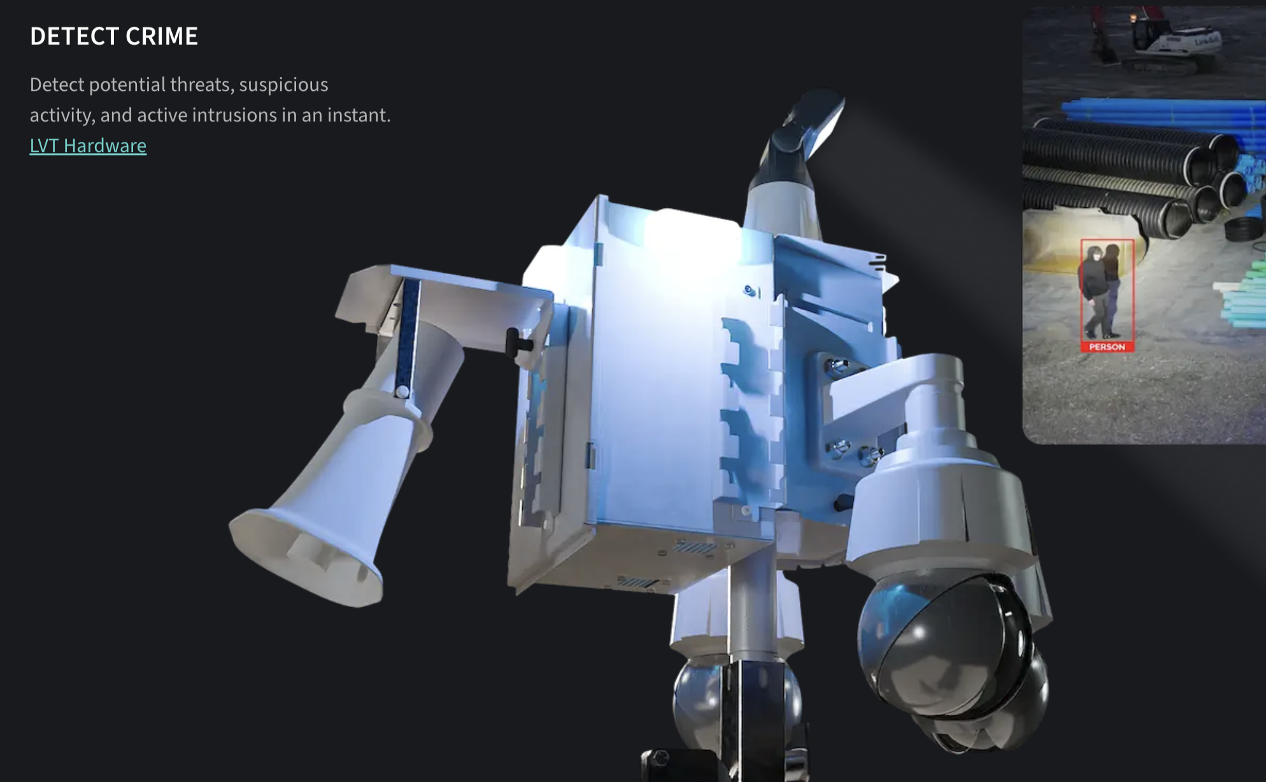

Industrial security began with staffed guard shacks where a guard watched the perimeter, logged activity, controlled access, and called a central office when something looked wrong. As cameras, sensors, and access controls were added, those fixed posts gained a broader view. Today's mobile security units extend that presence to sites where a staffed post is impractical: onboard cameras and analytics detect people and potential intrusions, while lights, speakers, and connected tools can deliver an immediate local response (locking a gate, sounding an alarm, or isolating a zone) under defined rules, with remote operators remaining in the loop. The post has evolved from a place that only watches and reports into a technology node that collects site data and supports timely, controlled perimeter defense.

Mapping to distributed AI edge agents
Hard-tech continuous cybersecurity edge agents follow the same path:
- Observation phase: Compact edge boxes sit at substations, plants, or remote hard-tech sites. They continuously ingest network flows, OT protocol traffic, logs, and configuration data, the digital equivalent of the guard's eyes and logbook. Local models correlate and reason over that telemetry, producing richer findings and evidence packages. The primary value is higher-quality, always-on observability without shipping raw data off-site.
- Defensive phase: With validated confidence, external controls, and human-gated authority, the same boxes move beyond watching. They prioritize high-consequence anomalies, package actionable evidence, recommend or (under strict limits) initiate containment steps, enrich local threat context, and coordinate with other edge nodes or central systems. The progression is continuous local sensing → multi-agent analysis → constrained defensive response.
The hardware remains in place. The system matures from “better local eyes” to “local decision support and limited defensive action,” always under external governance so the agent cannot exceed its mandate.

14. Real and Pending AI Threats
The Cyber AI Node is designed to reduce exposure and contain attacks during the time it takes to safely patch or replace vulnerable equipment.
The threat is credible. Anthropic reports that Claude Mythos Preview discovered previously unknown vulnerabilities and produced working exploits in controlled software evaluations. Its research also shows how AI can accelerate attacks against known vulnerabilities on systems that remain unpatched. Those findings support the need for stronger defenses; protection of utility equipment requires separate validation. anthropic.com
Frontier AI is accelerating how quickly attackers can discover and exploit software vulnerabilities, creating a serious challenge for utilities whose equipment cannot always be patched immediately. Our proposed cyber node places an additional layer of protection at the physical site. Working with a hardened security gateway, it restricts access to connected devices, limits communications to approved pathways, and separates vulnerable sensors from critical electrical controls. Its AI analyzes network activity alongside independently collected equipment and physical-security signals to identify suspicious behavior and give operators actionable evidence. Tested response procedures can revoke remote access or contain a compromised device before an incident spreads. This approach is designed to reduce opportunities for exploitation and limit operational consequences while utilities validate patches, schedule maintenance, or replace aging equipment.

15. Remote Deployment Scenarios
An on-site AI computer could extend the security-node concept into a system that understands both the physical site and the electrical equipment operating there. At a substation, battery installation, solar farm, or industrial facility, it could combine sensor readings with utility data to identify developing problems, recommend actions, and support approved local responses.

2017 case study: Oak Ridge National Laboratory
There is a practical foundation for this idea. In 2017, Oak Ridge National Laboratory and Chattanooga's EPB tested substation sensors that combine environmental measurements, thermal imaging, equipment monitoring, and physical and cybersecurity awareness. The Cyber AI Node builds on that approach by adding local analysis and connecting findings to operational decisions. Oak Ridge National Lab
“EPB has estimated that the increased reliability is worth roughly $50 million a year to Chattanooga-area businesses and residents, and that the number of customer minutes lost to power outages has decreased by 50 percent.”

Proposed capabilities
Function | Inputs the computer could use | How it could help
Cybersecurity | Network traffic, device identities and inventory, software versions, access logs, configuration changes, sensor health, physical intrusion alerts, and control commands | Monitor connected sensors and remote devices for suspicious activity or tampering. Use an integrated gateway to enforce device authentication, restricted communications, network segmentation, and encrypted connections where supported. Correlate cyber and physical events, alert operators with evidence, and support tested, utility-approved containment of compromised devices while preserving essential grid operations.
Physical security | Cameras, thermal imaging, fence and cabinet sensors, access records | Detect intrusions or tampering and correlate them with electrical or network events. Activate approved lights, speakers, and alerts.
Load management | Local demand, voltage, current, transformer loading, battery charge, solar output, EV charging | Forecast approaching constraints and recommend battery dispatch, flexible-load reductions, or adjustments through existing controllers.
Equipment maintenance | Temperature, vibration, acoustic signals, oil-condition measurements, operating history | Identify changes that may indicate overheating, cooling problems, or deteriorating equipment, helping prioritize inspections.
Weather and environmental risk | Temperature, wind, humidity, solar irradiance, smoke, water levels, forecasts | Anticipate demand changes, renewable generation swings, flooding, or fire exposure and give operators earlier warning.
Data collection and continuity | Hundreds of measurements, device status, timestamps, communications health | Maintain a local event history, flag missing or questionable readings, and continue selected monitoring during a communications outage.

These applications have different levels of maturity. NIST describes passive network monitoring and behavioral anomaly detection for industrial systems; ORNL has demonstrated analysis across vibration, voltage, and magnetic-field measurements; and national-laboratory research has demonstrated distributed coordination of generation, storage, and flexible loads. Integrating those capabilities into one dependable product would require engineering and site testing. nvlpubs.nist.gov

Security design
This proposed design reflects NIST guidance on IoT device security, secure updates, and protection of operational technology. An always-on edge appliance (AI node), integrated with a hardened security gateway, helps protect the growing network of IoT sensors, cameras, and remote devices surrounding electrical infrastructure. It maintains an inventory of connected devices, tracks their identities and software versions, and flags unauthorized additions or configuration changes. The gateway permits only approved communications, separates sensor networks from critical control systems, and requires authenticated, encrypted connections where supported, with additional isolation for legacy devices. Remote administrators use multifactor authentication and receive only the access needed for their tasks.
Passive network monitoring and AI analysis correlate device behavior, suspicious sensor readings, cabinet intrusions, and unexpected commands to identify possible compromise and alert utility security and operations teams with supporting evidence. The gateway rejects unauthorized connections and commands; tested, utility-approved procedures govern terminating suspicious sessions or isolating affected device segments, subject to operational safety checks. The node itself uses secure boot, restricted access, protected event logs, and authenticated software updates, while device patches are tested and scheduled around operating requirements. Independent electrical protection remains in place, and operators review proposed changes to power delivery. Together, these measures improve visibility, limit how a compromised edge device can reach other systems, and support a controlled response at the physical location.

Great value comes from connecting signals that are currently viewed separately
Consider an illustrative scenario: demand rises on a hot afternoon while a transformer's temperature increases unusually quickly. The computer could compare electrical loading, ambient conditions, thermal images, and cooling-system status to flag a possible equipment problem. It could estimate the approaching operating limit, recommend discharging an available battery or reducing participating EV charging, and send the control room the measurements behind its recommendation. If a cabinet intrusion and an unexpected control command occurred at the same time, it could elevate the event for a coordinated security investigation.
Collecting hundreds of variables is feasible, but trustworthy, synchronized data matters more than the number of sensors. Each reading needs an identified source, timestamp, units, calibration information, and quality status. The system also needs to recognize when a sensor has failed or its AI model is uncertain. Different measurements require different sampling rates and processing methods.
For load distribution, the computer would work through utility systems and authorized controllers. Its recommendations must respect network topology, equipment ratings, voltage limits, battery availability, and neighboring grid conditions. Local decisions need coordination so that helping one site does not create a problem elsewhere. Distributed-control research specifically addresses these coordination and engineering constraints. NLR

16. Threat Scenarios and Product Disclaimers
A practical first deployment would collect data and provide recommendations in read-only operation, followed by carefully tested automation for defined actions. Grid protection should retain independent, engineered controls. The added computer also needs network separation, restricted access, authenticated updates, backup power, and a defined fallback when communications or analysis fail. NIST's guidance emphasizes preserving operational safety and reliability when introducing monitoring and security technology. nvlpubs.nist.gov
Each capability connects to a specific protection:
Threat | Required protection in the proposed node
An attacker targets an unpatched device | Remove unnecessary internet exposure, disable unused services, and permit only essential connections.
An exploit travels through an approved connection | Use protocol-aware inspection and validated blocking rules for covered vulnerabilities. These measures cannot guarantee detection of unknown exploits.
A sensor or camera is compromised | Enforce separation between device groups and electrical controls, limiting the attacker's ability to reach other equipment.
An attacker manipulates readings or commands | Compare network events with independent measurements, equipment behavior, and physical-access records; escalate inconsistencies.
An attacker targets the node itself | Protect its identity, software integrity, administrative access, updates, and logs; keep enforcement rules independent of AI-generated recommendations.

These protections build on established industrial-security practices. NIST specifically recommends limiting exposure, restricting vulnerable services, and considering virtual patching when operational equipment cannot be patched promptly. Its IoT guidance also addresses device identity, access restrictions, secure updates, and integrity. nvlpubs.nist.gov
The AI provides analysis; engineered security controls enforce the boundaries. Authentication and encryption alone cannot stop an exploit delivered through an authorized connection. Additional sensors improve visibility, but each sensor also needs protection.
Until independent testing demonstrates results on representative equipment, we describe the node as “designed to reduce risk from AI-assisted attacks.” Investor evidence should include attack paths blocked, time to detect and contain incidents, false alarms, and continued safe operation when the AI, node, or communications fail.

Sources
- Pmarketresearch: Worldwide OT cybersecurity market research
- DRI: Operational technology (OT) security market
- Strategic Revenue Insights: OT cybersecurity in oil and gas
- GlobeNewswire: Global critical infrastructure protection market 2026–2031
- Market Intelo: AI-enabled cyber defense for critical infrastructure
- Anthropic: Claude Mythos Preview research
- Oak Ridge National Laboratory: ORNL and Chattanooga EPB test role of sensors in grid innovation
- NIST: IoT Device Cybersecurity Requirement Catalogs
- NIST SP 800-82r3: Guide to Operational Technology Security
- NLR: Distributed optimization and control
- Area Development: Creekstone Energy plans Millard County, Utah, data center operations
- AI Magazine: Zeo and Creekstone, powering the Delta Gigasite
- NPR via KUNC: A startup wants to build a massive nuclear-powered data center on public land in Utah
- Renewable Energy Magazine: Fervo Energy declares commercial operation at Cape Station

